«PATIENT_Title» «PATIENT_Surname»,
«PATIENT_BlockAddress»

Your NHS Number [NHS Number]

Dear «PATIENT_Title» «PATIENT_Surname»,
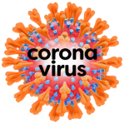 | This is an important letter about coronavirus.
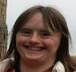 | This letter is for every adult who has Down’s syndrome.  We are writing to you because you have Down’s syndrome.
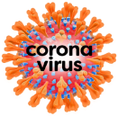 | We have been finding out more about coronavirus.  You might hear it called  COVID 19.
 | We know more about who needs extra support to stay well.
 | What we have found out…
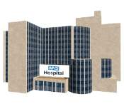 | Most people who get coronavirus will get a little bit ill.  They will get better at home.
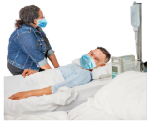 | Some people get very ill with coronavirus and need to go to hospital.
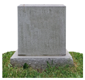 | Sadly, some people can die from coronavirus.
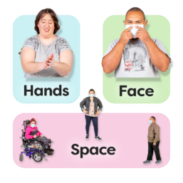 | There are things we can do to keep safer from coronavirus -  - wash your hands regularly  - cover your face when you're with people you don't live with  - stay two metres apart from others.
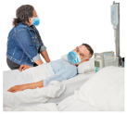 | People who have Down’s syndrome are more likely to have health conditions that make coronavirus worse.
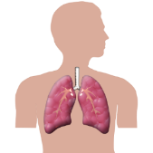 | People who have Down’s syndrome might have problems with breathing.
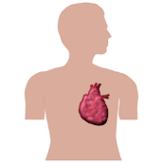 | Or have heart conditions.
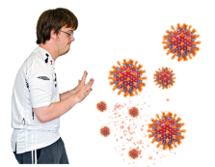 | And people who have Down’s syndrome might find it harder to fight infections.
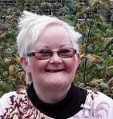 | The danger gets worse the older you are.
 | What this means for you
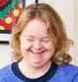  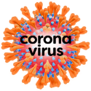  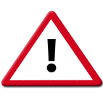 | Coronavirus may be dangerous for you if you catch it, because you are an adult who has Down’s syndrome.
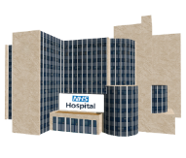 | You may become very ill if you catch coronavirus. You might need to go to hospital.
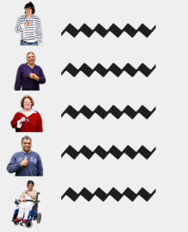 |  | We have a list of people who may need extra help to stay safe from coronavirus.  You are now on this list.  This list is called the shielded patient list.  Sometimes the people on this list are called clinically extremely vulnerable.
You will get other letters because you are on this list.

The letters will tell you how to stay safe.

If you have been sent this letter by your doctor as well, do not worry.

It is good to be on the list because it means you could get some extra help to stay safe from coronavirus.
There is more information about this at the end of the letter.
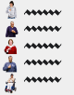  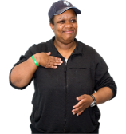 |  | It is important to be on this list because it means you will be invited to get the coronavirus vaccine before other people.
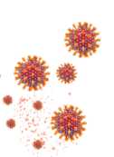 |  | The coronavirus vaccine is a medicine that can help stop you getting coronavirus.
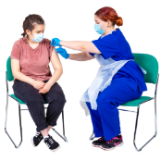 |  | The vaccine comes as an injection (or jab) in your arm.
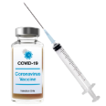 |  | You will need 2 lots of the coronavirus vaccine to keep you as safe as possible from coronavirus.
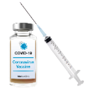 |  | We will write to you to tell you when it is time to have the coronavirus vaccine.
You can find out more about the vaccine in an easy read leaflet.

https://tinyurl.com/CovidVaccineEasyRead

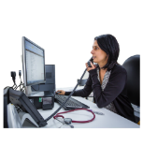 |  | If you are worried about being on this list- talk to your doctor (your GP).
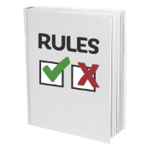 |  | There are lots of rules to keep you safe from coronavirus.
The rules to help us stay safe from coronavirus are on the Government website. This is in easy read. https://www.gov.uk/coronavirus
https://tinyurl.com/NationalLockDownEasyRead

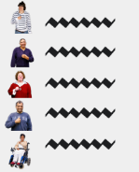 |  | There is also different advice for people who are in more danger from coronavirus.
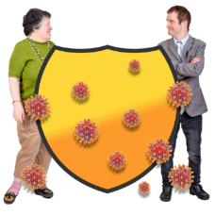 |  | This is sometimes called shielding.
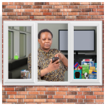 |  | You are asked to stay at home as much as possible.  This means there will be less danger to you from coronavirus.
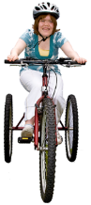  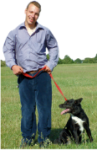 |  | You can still go outside to exercise
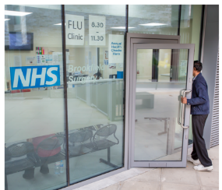 |  | You should still go to health appointments.
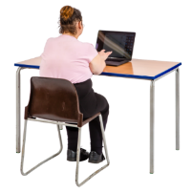 |  | Work from home if you can.
 |  | You can use this letter to tell your employer that you should work from home.
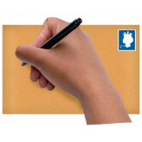 |  | This advice is for until 21 February.  We will write to you again if you need to keep following these rules after that.
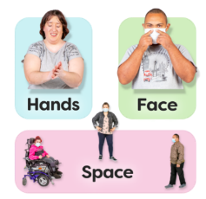 |  | It is really important that you follow the rules to stay safe.
There is advice for people who are at more danger from coronavirus
https://tinyurl.com/AdviceIfMoreAtRisk
 |  | Most of this website is not easy read.
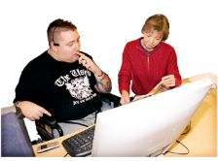 |  | You could ask someone to help you read the website.
There is easy read information about how to stay safe and well during coronavirus from Mencap.

https://tinyurl.com/
CoronaVirusEasyRead

There is easy read information about how to look after your feelings from the Down’s Syndrome Association.

https://tinyurl.com/
DSAWellbeingResources

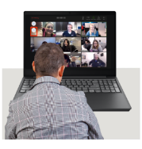  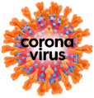 |  | The Down’s Syndrome Association has weekly webinars to talk about coronavirus.  You can phone their helpline to find out more. Call-  0333 1212 300  between 10am and 4pm  Monday-Friday

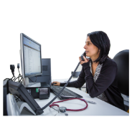 | Please make sure your doctor (GP) has your correct contact details.  So we can contact you quickly if we need to.  We need-
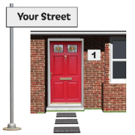  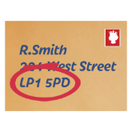 | Your home address.
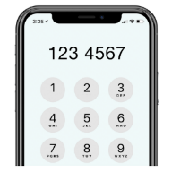 | Your mobile phone number.
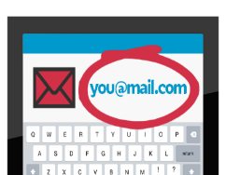 | Your email address, if you have one.
 | If you have questions about this letter you can ask your doctor.
 | Your doctor can help you understand how to keep well.
This is the phone number for your doctor (GP).

«PRACTICE_Main_Comm_No»
Remember- if you need help with your health the NHS is still open.

Ask your doctor for help.

Yours sincerely,
«PATIENT_Registered_GP»

Other things to help you (1)
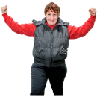  Vitamin D | One of the best things you can do is to try and stay healthy.  Vitamin D is important to keep you healthy.
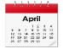 | Some people take Vitamin D already.  If you don’t, we want to give you free Vitamin D because you are on the list for more support.
 | This will be from January until April.
You need to tell us you if want this free vitamin D.

You can do this online at www.nhs.uk/get-vitamin-d

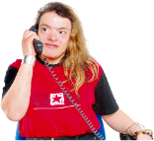 | You can ask a family member or supporter to help with this.  Or you can talk to your doctor about vitamin D.
Other things to help you (2)
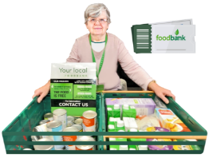  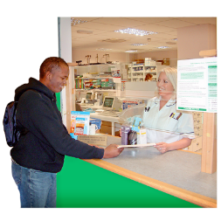 | If you need help with things like shopping and picking up medicine the NHS Volunteer Responders can help.
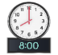 | You can call them on  0808 196 3646  between 8am and 8pm.
 | You can get more information on https://nhsvolunteerresponders.org.uk/ services

Other things to help you (3)
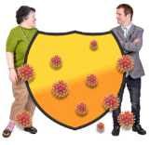 | Shielding support from your council  You may be able to get extra support from your council to help you to stay safe.
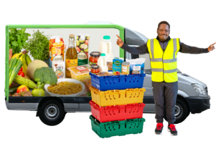 | This might help you get your supermarket deliveries.  These are sometimes called priority slots.
 | Your council may be able to help in other ways too.
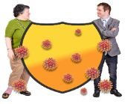 | You need to tell your council you if need this help.  You can tell them on this website -  https://www.gov.uk/coronavirus-shielding-support
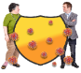 | You need your postcode to use this website.  You also need your NHS number to use the website.  You can find this at the top of this letter.
 | This website is not in easy read.
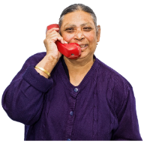 | You could ask someone to help you with the website.  Or you could phone your local council to see how they can help.

Other things to help you (4)
 | The NHS is here to help you with your health
 | If you are worried about your health or about coronavirus talk to your doctor (GP), hospital doctor or use NHS 111.
 | There are some NHS services which you can on your smart phone or computer, if you have one.
 | You can have some medical appointments on your computer.
You can order more medicine on your computer.

This is sometimes called repeat prescriptions.

 | To find out more go to www.nhs.uk/health-at-home
 | This website is not in easy read.
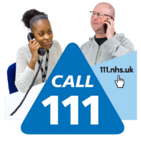 | If you have an urgent medical need, call NHS 111
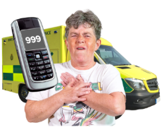 | If you have a medical emergency phone 999 for help.

